Project Design Book
Project Design Book
(team and individual)

Unit Code: COS30045
Unit Name: Data Visualisation
Submission Date:17.05.2026

[This is a template, Sanghun will remove any text within third brackets before submission. PLEASE USE CORRECT HEADING AND SUB-HEADING STYLES. BE CAREFUL WHILE PASTING CONTENTS BECAUSE OFTEN THE FORMATTING CHANGES. For tables, I would request everyone to create a simple table in word document and then manually copy paste each cell otherwise it can create chaos.]

Student Name | Student Id | Statement of Contribution to the Report
SANGHUN SHIN | 104767163 | - Drafted Design Book Sections 1 and 3.  - Set up GitHub repository and website structure (HTML/CSS, D3.js).  - Completed KNIME workflow for all datasets.  - Prepared Stand Up 1 PowerPoint.
SEBASTIAN HANEY | 104585161

Table of Contents
1 Introduction 3
1.1 Background and Motivation 3
1.2 Visualisation Purpose 3
2 Data 4
2.1 Data Source and Governance 4
2.2 Data Processing and Analysis 5
2.3 Data Exploration 5
3 Visualisation Design 6
3.1 Website Design 6
3.2 Visualisation Design 6
3.3 Interaction Design 7
4 Iteration and Validation 7
4.1 Testing and Refinements 7
4.2 Usability Evaluation 7
5 Conclusion and Future Improvements 8

1 Introduction

1.1 Background and Motivation
Analysis of road traffic accident data is essential not only for identifying the objective causes of accidents, but also for reducing casualties and social costs, and informing evidence-based, prevention-oriented traffic safety policies. Australian government agencies publish a detailed, open-access dataset recording hospitalisation injuries from road traffic accidents. This dataset covers annual injury counts by jurisdiction, demographic characteristics, road user type, and selected population groups. This project analyses and visualises these trends to support evidence-based understanding of road safety outcomes in Australia.
The target audience for this visualisation includes:
- General public: seeking awareness of road safety risks in their state or region
- Policy makers and government analysts: monitoring trends to inform road safety funding and initiatives
- Public health researchers: identifying high-risk demographic groups for targeted interventions
- Transport and road safety departments: comparing hospitalisation outcomes across states, road user types, and population groups

Key tasks users will perform using this visualisation:
- Explore how hospitalisation rates have changed over time nationally (2011–2021)
- Compare hospitalisation counts across states and territories
- Examine disparities between First Nations and non-First Nations hospitalisation rates
- Identify which road user types are most frequently hospitalised
- Investigate patterns by age group and remoteness

1.2 Visualisation Purpose
This project's visualization aims to go beyond a simple exploratory dashboard by presenting a structured data story that communicates meaningful patterns and traffic accident trends in Australian road crash hospitalizations based on Australian road accident data.
By interacting with this visualisation, users should be able to answer the following questions:
- How have national road crash hospitalisation counts changed between 2011 and 2021?
- Which states and territories consistently record the highest hospitalisation counts?
- Are there persistent disparities in hospitalisation rates between First Nations and non-First Nations people?
- Which road user type — car occupant, motorcyclist, pedestrian, or cyclist — is most frequently hospitalised?
- How does remoteness (Major Cities, Regional, Remote) relate to hospitalisation rates?
- Which age groups are most vulnerable to road crash hospitalisations?

The completed visualisation will benefit stakeholders by:
- Enabling policy makers to quickly identify high-risk groups and regions to prioritise funding
- Helping researchers identify trends and disparities that warrant further investigation
- Raising public awareness of road safety risks in a clear, accessible format

2 Data

2.1 Data Source and Governance
The primary datasets for this project are published by the Bureau of Infrastructure and Transport Research Economics (BITRE) as part of Australia's Hospitalised Injury Data series. All datasets are publicly available and cover hospitalisation records from road crashes in Australia from 2011 to 2021.
The dataset comprises:
- National hospitalised injury counts (2011–2021)
- State and Territory hospitalised injury counts (2011–2021)
- First Nations Peoples hospitalised injury counts (2011–2021)

Dataset File | Description | Rows | Coverage
National hospitalised injury counts | National hospitalised injuries from road crashes — full raw dataset with monthly breakdowns by remoteness, cause, age, sex, road user, and counterparty | 117,919 | 2011–2021
State and Territory hospitalised injury counts | Hospitalisations broken down by state/territory, further disaggregated by road user, sex, age group, and counterparty (6-monthly aggregates) | 1,372 | 2011–2021
First Nations Peoples hospitalised injury counts | Hospitalised injuries comparing First Nations and non-First Nations people, broken down by road user, age, remoteness, and counterparty | 352 | 2011–2021

Data Governance
Data collection process: Data is collected by state and territory health departments and reported through the National Hospital Morbidity Database (NHMD). Records are linked to road crash events using injury cause codes. The dataset is compiled and published by BITRE on an ongoing basis.
Data quality assessment: The raw dataset contains 117,919 records across 13 columns. Some records contain missing values (NaN) in the Died_cases and Died_bed_days columns, which represent cases where no in-hospital deaths within 30 days were recorded. A small proportion of records have 'Missing' values in the ABS remoteness area and age group columns, which will be handled during cleaning. The dataset also includes records where the cause of injury is 'All other trauma events' (non-traffic), which are filtered out to retain only traffic-related hospitalisations.
Security, privacy, and ethical considerations: The data is fully de-identified and aggregated — no personally identifiable information is present. The datasets are published under open-access Australian Government licensing. There are no ethical concerns regarding re-use of this data for academic visualisation purposes.

Important limitation — raw count comparisons: The BITRE dataset reports absolute counts of hospitalised injuries. Direct comparison of raw counts across jurisdictions, demographic groups, or population subgroups may be misleading where substantial differences in population size exist (e.g., Northern Territory compared with Victoria). This limitation will be clearly noted in the visualisation's narrative. Population-adjusted rates may be used where appropriate as derived variables.
Connection to Section 1.2 questions: The three datasets together provide multi-year, multi-dimensional records that directly support answering all six research questions defined in Section 1.2, covering national trends, state-level breakdowns, First Nations comparisons, road user types, remoteness, and age group analysis.

2.2 Data Processing and Analysis
Key Attributes and Data Types
Attribute | Dataset | Data Type | Example Values
Calendar year | All | Ordinal (year) | 2011, 2012, 2013..., 2021
Month / 6-monthly | Hosp. / State | Ordinal | April, August,December; Jan–Jun, Jul–Dec
ABS remoteness area | Hosp. / FN | Ordinal | Major Cities, Regional, Remote
Cause of injury | Hospitalisation | Nominal | Traffic, All other trauma events
Age group | All | Ordinal | 0–7, 8–16, 17–25, 26–39, 40–64, 65–74, 75+
Sex | Hospitalisation | Nominal | Male, Female, intersex or indeterminate or missing
Road user | All | Nominal | Car passenger, Motorcyclist, Pedestrian, Pedal cyclist, Bus occupant
Counterparty | All | Nominal | Car/pick-up truck, Fixed or stationary object, Pedestrian
First Nations status | First Nations | Nominal | First Nations people, Non-First Nations people
State or territory | State | Nominal | NSW, VIC, QLD, SA, WA, TAS, NT, ACT
Hospitalisations | All | Quantitative (Ratio) | 46, 91, 173, 127 …
Bed days | All | Quantitative (Ratio) | 208, 529, 1123, 772 …
Count of cases | Hospitalisation | Quantitative (Ratio) | 765, 1010, 3366 …

Data Cleaning Process (KNIME Workflow)

2.3 Data Exploration
Data Processing and Dataset Overview
The dataset used within this project were obtained from the Australian road crash hospitalisation records. Multiple datasets were explored containing information related to hospitalisation, road users, age groups, states and territories and yearly injury statistics. The datasets were provided in excel format and processed using KNIME before being exported into cleaned CSV files to be used for D3 visualisations.
- The primary attributes identified within the datasets were:
- Calendar year
- State and territory
- Road user type
- Age group
- Cause of injury
- Number of hospitalisations
The datasets contained a combination of categorical and numerical data types with attributes such as state, road user type were categorical variables whilst hospitalisation totals were numerical variables.
Data Cleaning and Transformation
Several preprocessing steps were performed within the KNIME workflow to improve data quality, readability and ensure compatibility with the visualisation stage of the project
Filtering Relevant Injury data
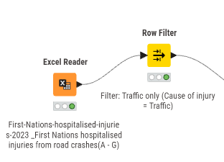
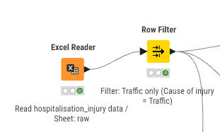
The original datasets contained multiple injury categories since the project focus was on road crash hospitalisations, a row filter node was used to retain only records where the cause of injury was identified as traffic-related injuries. This filtering reduced unnecessary data that was not part of the focus and ensured the analysis remained aligned with the project objective.
Figure 1. Row filter filtering traffic only from the hospitalisation_injury data sheet (left) Row filter filtering traffic only from the First-Nations document (right)
Handling Missing Values
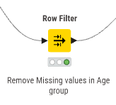
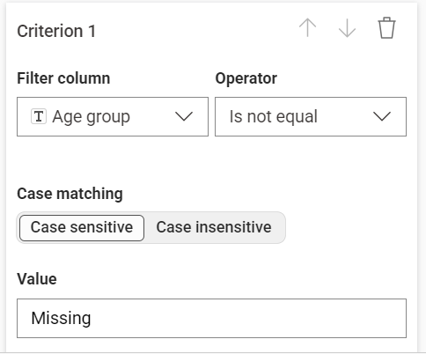
During the exploration of demographic datasets, missing values were identified within the age group attribute. These missing records were removed using an additional Row filter node to prevent incomplete demographic information. Removing these incomplete rows improved consistency across the aggregated outputs.
Figure 2. Criterion for row filter (Left) Row filter node (Right)

Data Type Conversion
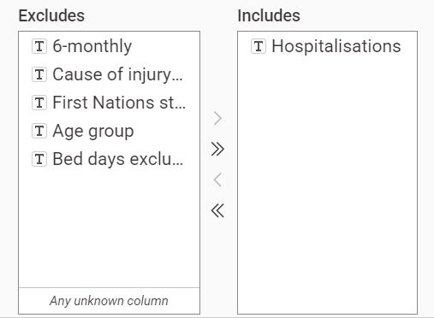
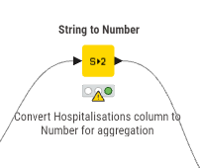
The hospitalisation values within the first nations datasets were initially stored as string values rather than numeric data types and was transformed to be able to aggregate numbers and group these values for improved visualisation
Figure 3. Criterion for String to number node (Left) String to number node (Right)
Column Standardisation and Renaming
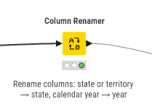
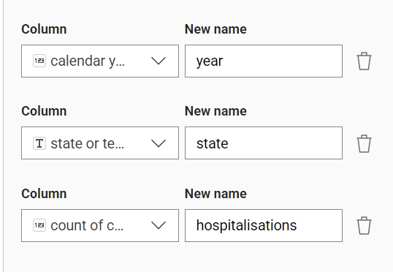
The state and territory dataset contained inconsistent column naming conventions. To improve readability and maintain consistency across the workflow, a column reader node was used to standardise attribute names such as changing ‘calendar year’ to ‘year’. This then simplified later aggregation while at the same time improving clarity.
Figure 4. Column renamer node filter (left) Column renamer node (right)
Data Aggregation and Integration
After cleaning and transformation, groupby nodes were used to aggregate the datasets into several analysis focused summaries. These aggregations were mainly to group by calendary year turning the dataset which split it into 6 months into yearly however the hospitalisation injury dataset grouped hospitalisations by age group by using a sum aggregation for hospitalisations. The state and territory dataset aggregated months to yearly however also used a sum aggregation for hospitalisations. After all the filtering the processed outputs included
- National yearly hospitalisation totals
- Hospitalisations by road user type
- Hospitalisation by age group
- Hospitalisation by state and territory
- First Nations hospitalisation statistics
Then multiple cleaned datasets were exported as CSV files using CSV writer nodes which are to later integrated into the D3 visualisation stage.
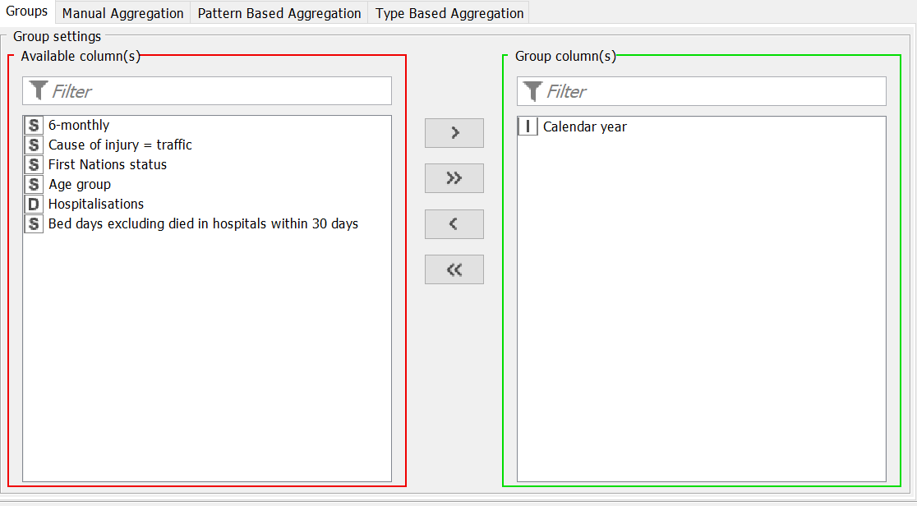
Figure 5. GroupBy column filter for first nations dataset & hospitalisation injury dataset grouping by calendar year

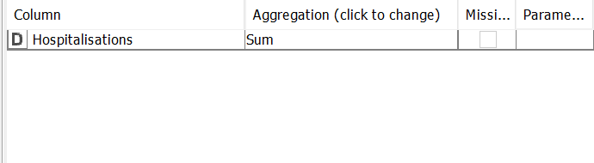
Figure 6. GroupBy manual aggregation for first nations dataset, hospitalisation injury dataset & state and territory dataset aggregating by sum

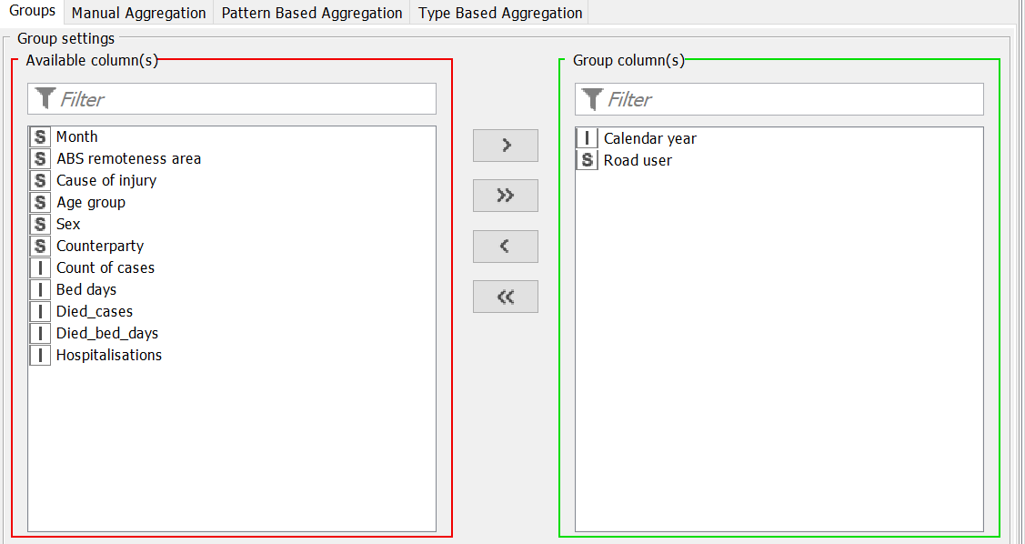
Figure 7. GroupBy column filter for Hospitalisation injury dataset grouping by calendar year and road user

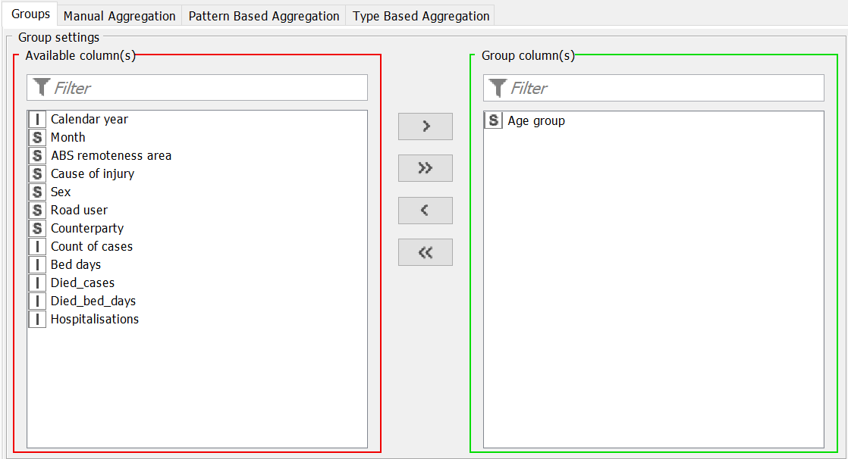
Figure 8. GroupBy column filter for Hospitalisation injury dataset grouping by Age group

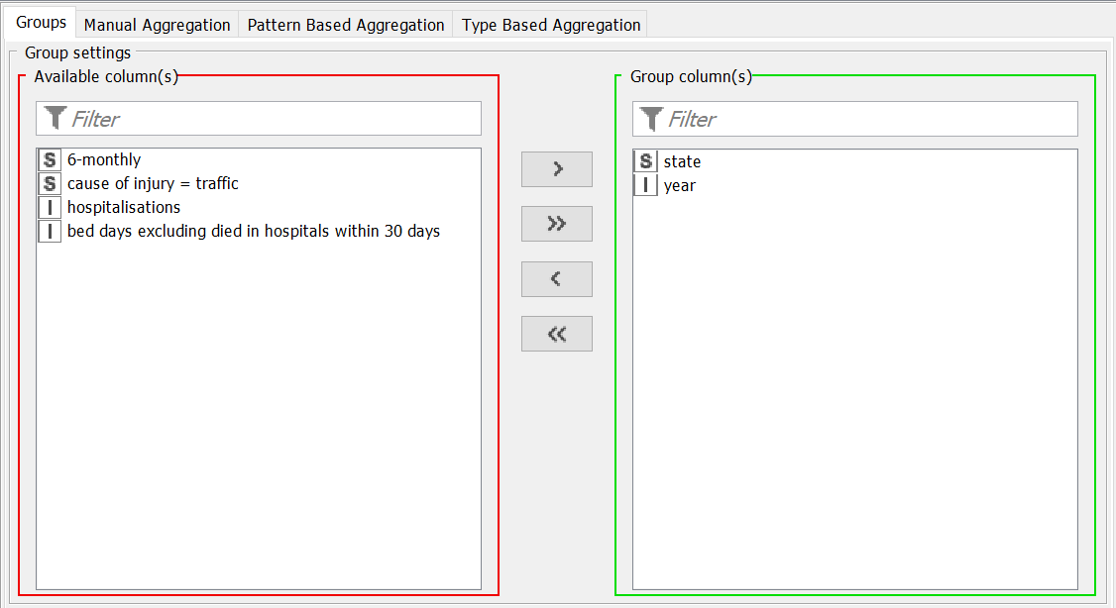
Figure 9. GroupBy column filter for state and territory dataset grouping by state and year

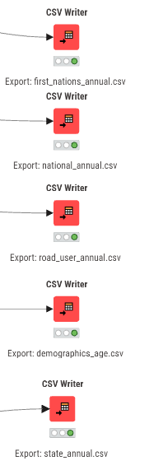
Figure 10. All cleaned datasets being exported to CSV witers
Data Analysis
Initial exploration revealed that larger Australian states such as NSW, Victoria and Queensland consistently recorded substantially higher traffic-related hospitalisation counts compared to smaller states such as Tasmania. This suggested significant population related differences between states and was highlighted with comparative visualisations.
Several demographic patterns were analysed with age groups specifically showing younger and middle aged grpups generally recorded higher hospitalisation totals compared to older age groups. Furthermore the sexes of these age groups showed that male hospitalisation counts were also frequently higher than female counts across several datasets.
Road user analysis identified that car occupants, motorcyclist, pedestrians and pedal cyclists were largely represented categories within these datasets. Car occupants consistently recorded some of the highest hospitalisation totals, while categories such as bus occupants and heavy transport users recorded substantially smaller counts.
Within the first nations datasets, variation was identified between remoteness categories and regional areas. Several cetegories also contained n.p values indicating that data was unavailable, unpublished or was too small. These suppressed values had to be taken into consideration during preprocessing and aggregation to not skew data.
Several structural cahllegnes within the raw datasets were identified. In some datasets multiple catergoeis of information were organised within a single sheet but separated into grouped column sections with gapts between attributes. For example within the first nations dataset, certain coloumn groups related to age demographics while other separated sections contained remoteness area stastics and additional demographic breakdowns. This structure increased the complexity of preprocessing because the datasets were not fully standardiesed into a single format. As a result additional filtering coloumn selection and restructuring steps were required within the KNIME workflow to ensure that the relevant information was being used.
Analysis of the data helped with preprocessing data as it highlighered several data quality issues including
- Missing demographic values
- n.p values
- Inconsistent column names
- Mixed data formats across worksheets
- Large datasets spread across multiple sheets.

3 Visualisation Design

3.1 Website Design
The website will be built as a structured, single-page web application using D3.js, HTML, and CSS. The layout is designed to support a narrative data story — guiding the user through a structured sequence of insights rather than presenting an open-ended dashboard.

The website will be built as a single-page web application using D3.js, HTML, and CSS. The layout is designed to support a narrative data story, guiding the user through structured insights about Australian road crash hospitalisations from 2011 to 2021.
Navigation structure: A top navigation bar provides three tabs that filter and update all charts simultaneously without page reload:
- Total — overview of hospitalisation counts by state and territory
- Trend — year-on-year change in national hospitalisation counts
- Age & Gender — demographic breakdown by age group and sex
Layout principles: The page is divided into four main areas. A header displays the site title and data source. Below the header, the three navigation tabs sit alongside a Key Stats panel on the right, which displays summary figures such as total cases, peak year, and highest-risk group. A shared filter bar below the tabs allows users to refine all charts by age group, gender, and road user type simultaneously. The main content area displays a 2×2 chart grid. A footer displays the data source attribution. The layout uses CSS flexbox and targets standard desktop screen sizes of 1024px minimum width.
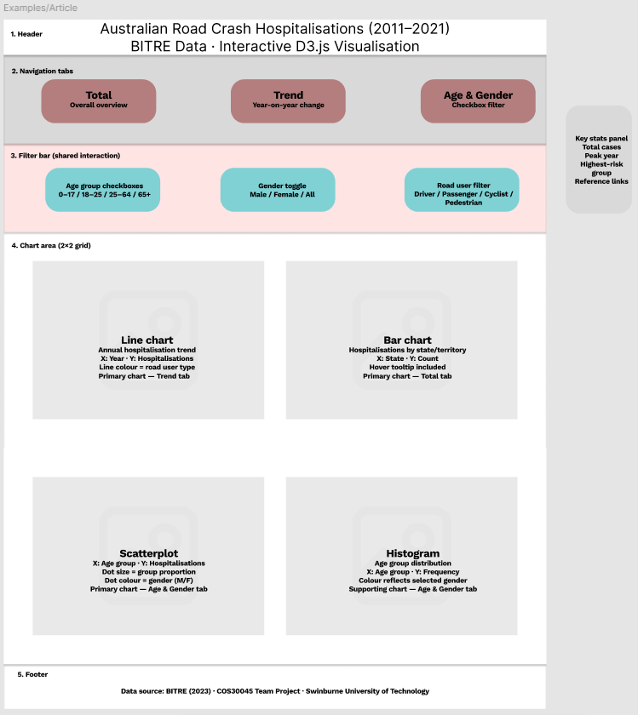
Figure 11. Wireframe prototype of the website layout, showing the header, navigation tabs (Total, Trend, Age & Gender), shared filter bar, 2×2 chart grid, Key Stats panel, and footer

3.2 Visualisation Design
All visualisations are built using D3.js. Chart types were selected based on the nature of each data dimension and the analytical question being addressed, following Munzner's (2014) guidelines for marks and channels and Tufte's (2001) principles of graphical integrity.
Chart 1 — Line chart (Trend tab) Displays annual hospitalisation counts from 2011 to 2021. The x-axis encodes year as an ordinal variable and the y-axis encodes hospitalisation count as a quantitative variable. Each line represents a road user type, distinguished by a ColorBrewer qualitative palette (Set2). This chart directly answers the question: how have national hospitalisation counts changed over time?
Chart 2 — Bar chart (Total tab) Displays total hospitalisation counts by state and territory. The x-axis encodes state as a nominal variable and the y-axis encodes count as a quantitative variable starting from zero, consistent with Tufte's (2001) principle of graphical integrity. Bars are sorted in descending order to support comparison. Hover tooltips display exact values.
Chart 3 — Scatterplot (Age & Gender tab) Displays hospitalisation counts by age group and sex. The x-axis encodes age group as an ordinal variable and the y-axis encodes hospitalisation count as a quantitative variable. Dot colour encodes gender using a two-colour ColorBrewer palette. Dot size encodes the proportion of that group relative to the total. This chart answers the question: which age group and gender combination is most at risk?
Chart 4 — Histogram (Age & Gender tab) Displays the frequency distribution of hospitalisations across age groups. The x-axis encodes age group as an ordinal variable and the y-axis encodes frequency as a quantitative variable. Bar colour reflects the currently selected gender filter, updating dynamically when the user changes the gender toggle.
Design principles applied:
- Graphical integrity (Tufte, 2001): all y-axes start at zero, no 3D effects, no chart junk
- Marks and channels (Munzner, 2014): position on a common scale is the primary encoding channel; colour is used only as a secondary channel for categorical distinction
- Colour palette: ColorBrewer accessible palettes — Set2 for nominal categories, Blues for sequential quantitative data
- No pie charts or 3D charts will be used

3.3 Interaction Design
Interactive features are designed to support the narrative structure and allow users to explore selected dimensions of the data in a meaningful and controlled way.
Feature | Interaction Method | User Action | System Response
Tab navigation | Click | User clicks Total, Trend, or Age & Gender tab | All four charts update simultaneously to reflect the selected view
Age group filter | Checkbox | User selects one or more age groups | State bar chart highlights/filters selected states
Tooltip | Mouse hover (D3) | User hovers over a data point or bar | Scatterplot and Histogram filter to selected groups
Gender toggle | Button toggle | User selects Male, Female, or All | All charts filter to selected gender; Histogram bar colour updates
Road user filter | Checkbox | User selects one or more road user types | Line chart and Bar chart filter to selected types
Reset button | Mouse hover | User hovers over a data point or bar | Tooltip displays exact value, year, and category label
Tooltip | Click | User clicks Reset filters | All filters clear and charts return to default view

4 Iteration and Validation

4.1 Testing and Refinements
The visualisation will be developed iteratively, with regular review and refinement based on feedback received during class stand-ups and peer review sessions.

[This section will be completed as the project progresses. It will document:]
- Changes made to the visualisation design or website layout based on tutor or peer feedback
- Before-and-after screenshots illustrating specific design improvements
- Adjustments made due to D3.js programming constraints or browser compatibility issues
- Accessibility improvements made following testing (e.g., colour contrast fixes, responsive layout adjustments)

4.2 Usability Evaluation
A structured usability evaluation will be conducted with test participants to assess the effectiveness and usability of the completed visualisation.

[This section will be completed in the final submission. It will include:]
- Usability evaluation method and protocol (e.g., think-aloud, task completion)
- Participant details (number, background, recruitment method)
- Evaluation tasks given to participants
- Summary of findings and usability issues identified
- Design changes made in response to usability findings

[Usability evaluation test materials will be appended in the Appendices.]

5 Conclusion and Future Improvements
[This section will be completed in the final submission.]

This section will summarise:
Key analytical findings from the data story — the most meaningful patterns, trends, and contrasts identified in the hospitalisation data
Lessons learned from the data processing, design, and development process
Challenges encountered and how they were resolved

Potential future improvements include:
- Incorporating population-adjusted hospitalisation rates to enable more valid cross-jurisdiction comparisons
- Extending the dataset to include more recent years beyond 2021 as BITRE releases new data
- Adding fatality data alongside hospitalisation data to provide a more complete picture of road crash outcomes
- Improving mobile responsiveness for access on smaller screen devices
- Expanding First Nations analysis to incorporate socioeconomic and infrastructure context

